Carti Hotel Management System

Business Architecture Document

Version 1.0

Revision History

|  |  |  |  |
| --- | --- | --- | --- |
| **Date** | **Version** | **Description** | **Author** |
| 20/10/2024 | 1.0 | Final Version | Phan Khanh Huyen |
|  |  |  |  |
|  |  |  |  |
|  |  |  |  |

**Table of Contents**

1. Introduction 4

1.1 Purpose 4

1.2 Scope 4

1.3 Definitions, Acronyms, and Abbreviations 4

1.4 References 4

1.5 Overview 4

2. Architectural Representation 4

3. Architectural Drivers 4

4. Market View 5

5. Business Process View 5

5.1 Business Context 5

5.2 Architecturally Significant Business Process View 5

6. Organization View 5

6.1 Organization Structure 5

6.2 Business Use-Case Realizations 5

6.3 General Patterns of Behaviour 5

7. Human Resource View 5

7.1 Remuneration and Incentives 5

7.2 Cultural Aspects 6

7.3 Competencies 6

8. Domain View 6

9. Geographic View 6

10. Communcation View 6

11. Architectural Trade-offs 6

Business Architecture Document

# Introduction

## Purpose

This document provides guidance on the software architecture which will be applied in building an

CHMS project.

## Scope

This document is used inside the project. The scope of this document contains two parts: software and

architecture. The main focus is software, meanwhile, architecture is aimed at supporting connecting

software modules.

## Definitions, Acronyms, and Abbreviations

This software is built on MVC pattern: three-layers design including Model – View – Controller.

## References

- Interview on 27/11/2024

- Interview Analysis on 28/11/2024.

- File Supplementary Business Specification in the Business Modelling folder

## Overview

NA.

# Architectural Representation

**Software Architecture View**

Administrator: manage CHMS and modules

Customer and Receptionist: the direct user of the CHMS.

The system is divided into three main parts:

- Human resource, facility and business management system, independent of the two lower systems

and will support to maintain these activities

- Receptionist’s management system related to check-in, check-out and manage services.

- Customer’s system related to making a reservation and making payment.

# Architectural Drivers

NA.

# Market View

NA.

# Business Process View

The following diagram describes all functions of the system:

## Business Context

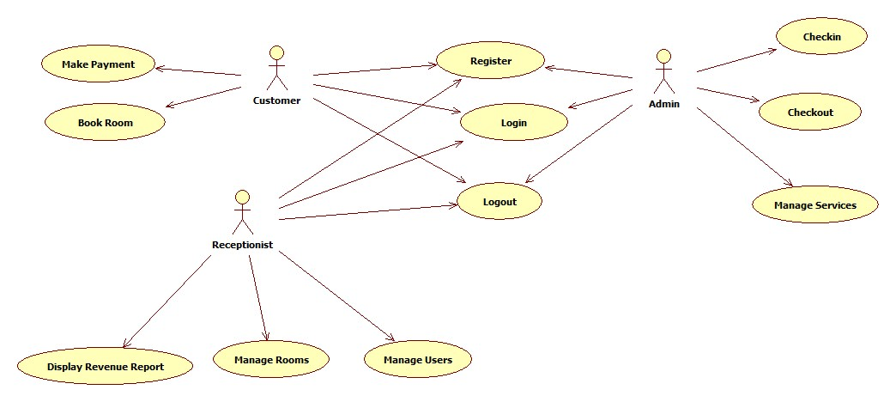

## Architecturally Significant Business Process View

# Organization View

NA.

# Human Resource View

NA.

# Domain View

NA.

# Geographic View

NA.

# Communcation View

NA.

# Architectural Trade-offs

NA.